FiveAlley (FVAA)
Wednesday 11 March 2026
13:00

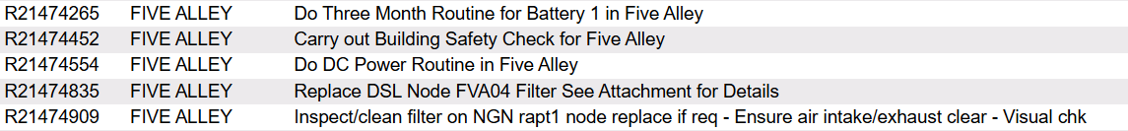

+ Please clean/replace filter on FVA-MSAN
+ Inspect FAN on EVDSL node FVA1_E01A - Ensure air intake/exhaust clear - Visual check of terminal & fibres
+ Inspect FAN on FTTH node FVA1-F01A - Ensure air intake/exhaust clear

Overall voltage: 53.37 V

1 | 2 | 3 | 4 | 5 | 6 | 7 | 8 | 9 | 10 | 11 | 12 | 13 | 14 | 15 | 16 | 17 | 18 | 19 | 20 | 21 | 22 | 23 | 24
2.2 | 2.3 | 2.23 | 2.22 | 2.22 | 2.22 | 2.22 | 2.22 | 2.23 | 2.22 | 2.22 | 2.22 | 2.22 | 2.23 | 2.22 | 2.23 | 2.22 | 2.22 | 2.23 | 2.23 | 2.23 | 2.23 | 2.23 | 2.23

Rectifiers | 4
DC Power Load | 24.5
Boost Voltage | 56.4
Float Voltage | 53.4

Alarm Limits
Low Voltage | 47V
High Voltage | 58
High Load | 100%
High Temperature | 30 °C

--- Alarms ---

Temperature: 30 C - is not wired
Low voltage 47 V
High Voltage: 58 V

Changing the high-temperature value does not trigger an alarm on Power One.
Low Voltage and High Voltage alarms are not visible to SMC.

